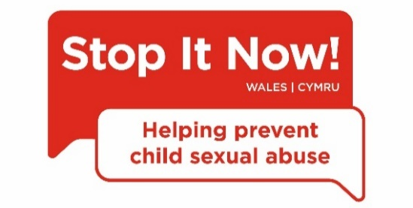
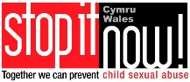

The ‘Child sexual abuse prevention –
It’s time we talked about it’ campaign
1. Who we are

Stop It Now! Wales is a child sexual abuse prevention project that works across the country to ensure that parents, carers and professionals are as best placed as they can be to protect children from sexual abuse and exploitation.

We believe that child sexual abuse is preventable and that all adults have a role to play in protecting children from sexual harm. This can be best achieved when adults are alert to the signs of child sexual abuse, including the behaviour that someone who might pose a risk to children can display, and knowing where they can seek help and advice.

We work closely with local authorities, LSCBs, police, the Welsh government, the voluntary sector, families and communities.

Stop It Now! Wales is run by the child protection charity The Lucy Faithfull Foundation.

2. What it’s all about
Our campaign – ‘Child sexual abuse prevention – It’s time we talked about it’ – is currently running across Wales.

You may have seen our campaign on social media or heard about it from a colleague.

Along with raising awareness of child sexual abuse, including where the risks lie, it aims to spread awareness that sexual abuse can happen to any child. It aims to make people aware that perpetrators take advantage of the fact that sexual abuse is a taboo subject to abuse children and to silence them. That means that by being aware that sexual abuse can and does happen, everyone in the community can help to keep children safe.
We want to encourage individuals across communities to talk about child sexual abuse in a safe way which is supportive of victims, and to encourage the public to report any concerns they have that a child is at risk.
3. Why your support is invaluable
It is only in recent years that we have come to appreciate the true scale of the sexual abuse of children.
The secrecy surrounding such abuse is evident in the fact that 1 in 3 children who are sexually abused by an adult do not tell anyone. Of those who do tell, most tell a family member or friend. Hardly any come to the attention of police, social services or health professionals.
Key stats
- 1 in 3 children sexually abused by an adult do not tell anyone
- 4 out of 5 children abused by a peer told no one else at the time
- Only 1 in 8 sexually abused children are known to the authorities
- 90% of sexually abused children are abused by someone they know
- Around a third of sexual abuse is committed by other children and young people
- Disabled children are over 3 times more likely to be abused than non-disabled children
- There is no stereotypical abuser - abusers come from all walks of life – and from all socioeconomic backgrounds
Most victims of child sexual abuse don’t talk about it and can’t ask for help. So adults have to.
By understanding the risks, and knowing what do to if we have a concern – we can prevent abuse from happening in the first place.
Our campaign aims to provide adults with the information we all need to put in place preventative measures, recognise the warning signs of child sexual abuse - and to build the confidence to do something about it.
The scale and secrecy which surrounds child sexual abuse means we all have a part to play in tackling it. And the more support our campaign has, the more people will be informed and protective.

4. How you can support this campaign
Please help us to share the campaign’s key messages which will be disseminated via the following channels:

4.1 Social Media
We will be using our social media channels throughout the campaign. It would be great if you felt able to share these posts and show your organisation’s support for the campaign via your own social media channels.
We have developed social media messages to promote the campaign from March 2020 onwards.
We will be posting from the following channels:
- Twitter: @StopItNowWales The campaign hashtag is #StopItNowWales
- Facebook: https://www.facebook.com/stopitnowukandireland/
- LinkedIn: https://www.linkedin.com/company/the-lucy-faithfull-foundation/
The social media messaging aims to highlight some of the key issues around child sexual abuse and signpost people towards information and resources.
We also want to demonstrate the commitment across Wales to working together to tackle this problem. Please share/retweet these posts and, where you feel appropriate, lend your support to the campaign.
You can also create your own content. If there is something in particular you’d like us to retweet or support on social media, please contact the Stop It Now! Wales team: wales@stopitnow.org.uk.
Please see below suggested some suggested posts in support of the campaign:
Twitter
- Important campaign from @StopItNowWales to raise awareness of how we can all prevent child sexual abuse. Find out more: http://bit.ly/2VuPANh #StopItNowWales
- We support the @StopItNowWales campaign ‘Child sexual abuse prevention – It’s time we talked about it’ – we all have a part to play. Find out more: http://bit.ly/2VuPANh #StopItNowWales
- Child sexual abuse is a difficult subject to talk about – but only by doing so can we really tackle it. Great resources are available from @StopItNowWales: http://bit.ly/2VuPANh #StopItNowWales
Facebook
- This is such an important campaign from @StopItNowUKandIreland - ‘Child sexual abuse prevention – It’s time we talked about it’. Through raising awareness of how we can all help prevent child sexual abuse, we can make our children safer. Find out more: http://bit.ly/2VuPANh
- We support the campaign from @StopItNowUKandIreland - ‘Child sexual abuse prevention – It’s time we talked about it’ – we all have a part to play and by becoming more informed, and working together, we can protect our children. Find out more: http://bit.ly/2VuPANh
- Child sexual abuse is a difficult subject to think about and even harder to talk about – but only by doing so can we really tackle it. There are some great resources available from @StopItNowUKandIreland: http://bit.ly/2VuPANh
Images which could be used to accompany posts are available here:
English
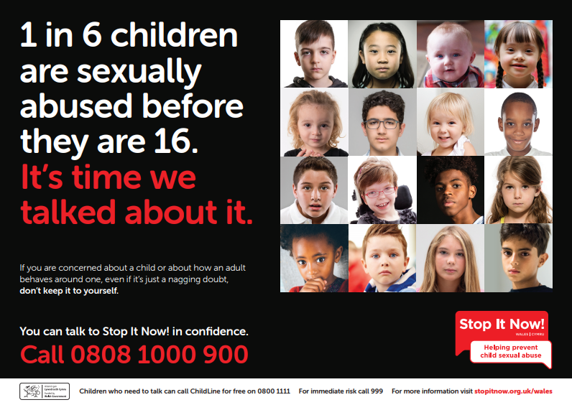 | 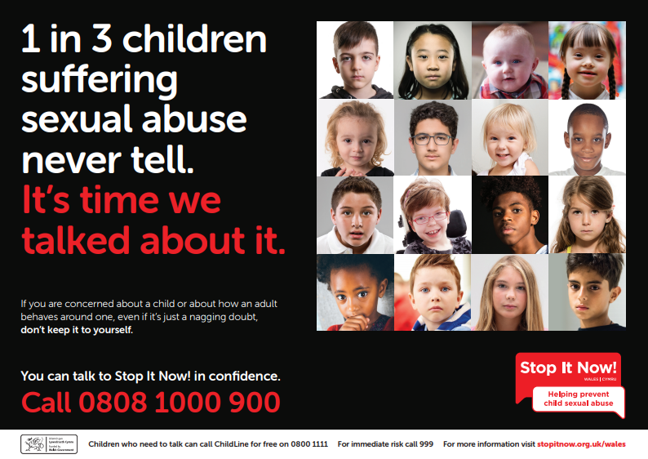
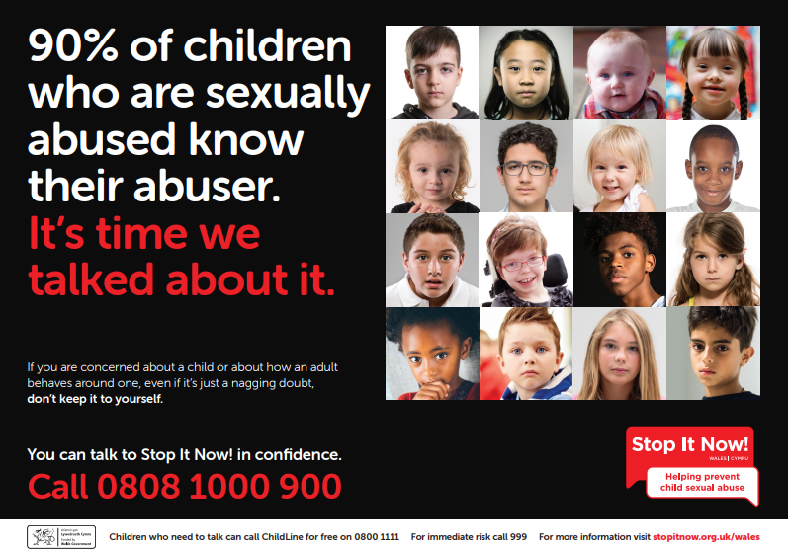 | 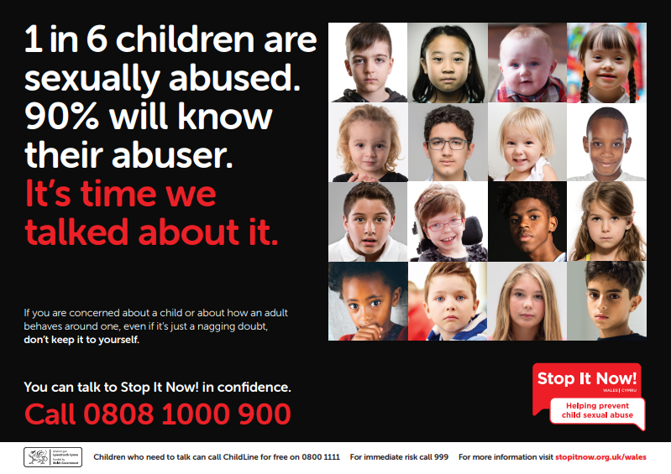

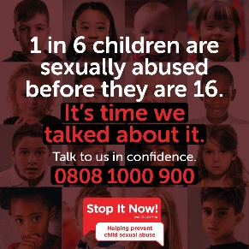 | 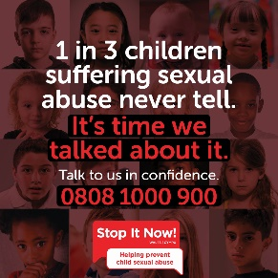 | 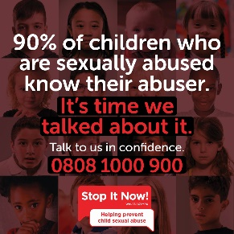 | 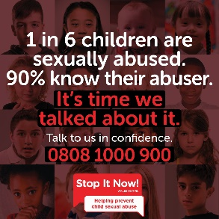
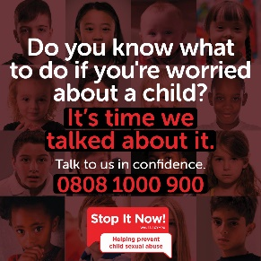 | 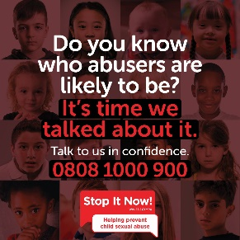 | 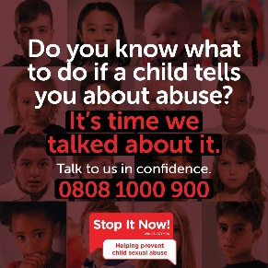 | 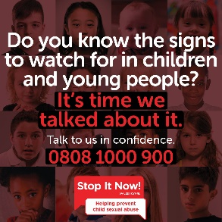
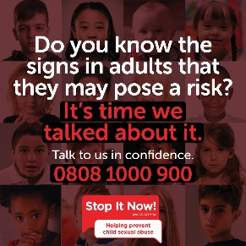 | 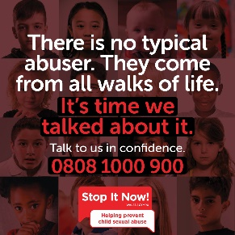 | 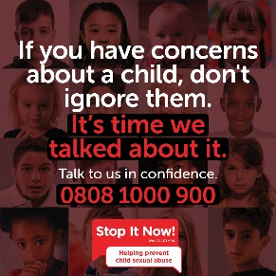 | 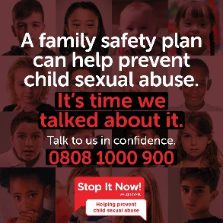
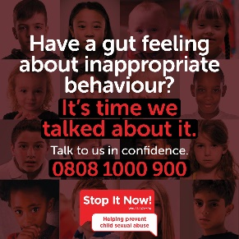 | 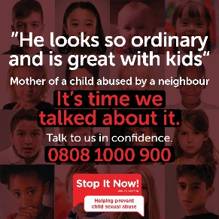 | 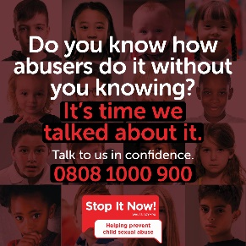 | 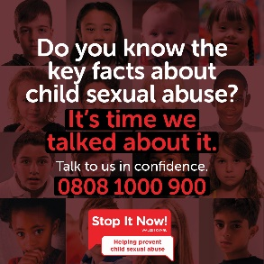

Welsh
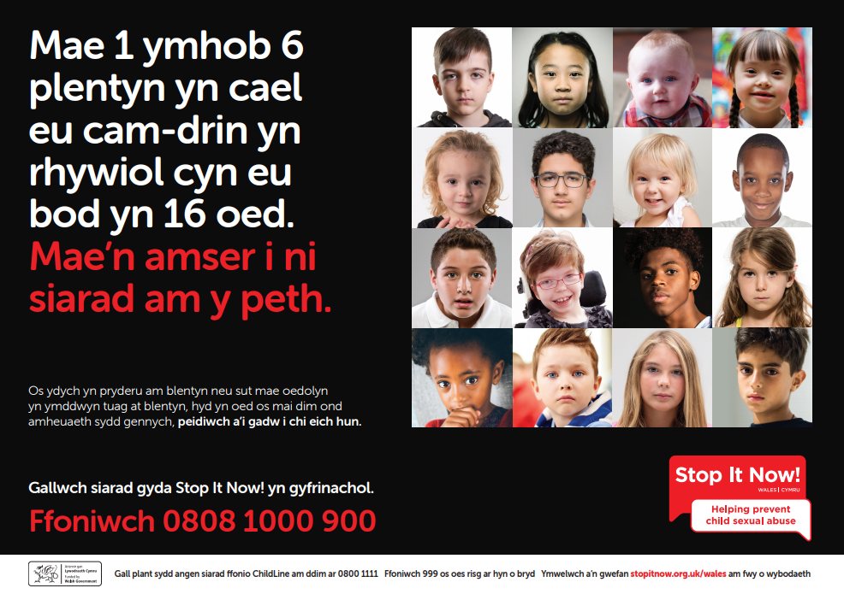 | 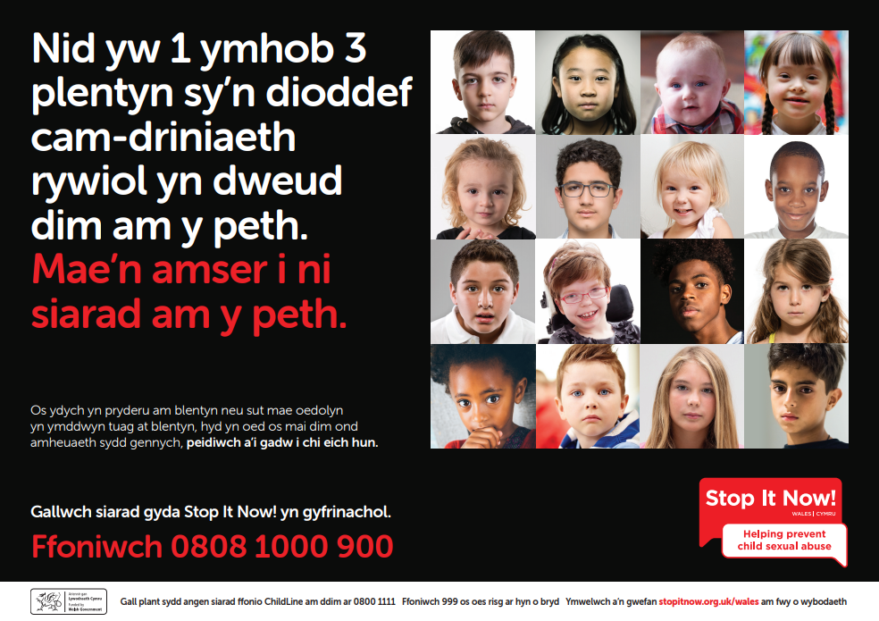
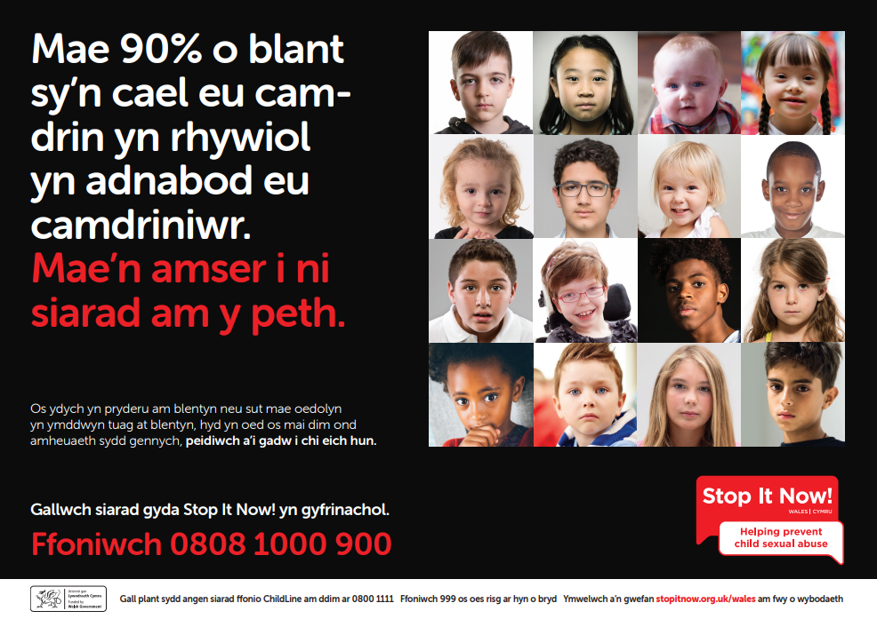 | 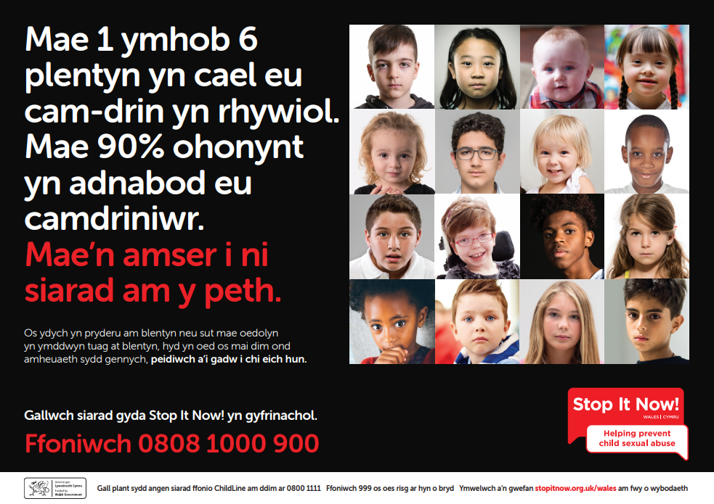

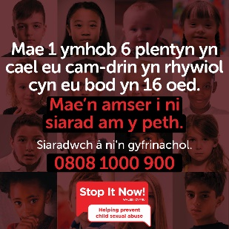 | 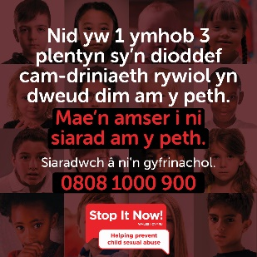 | 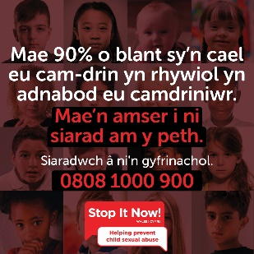 | 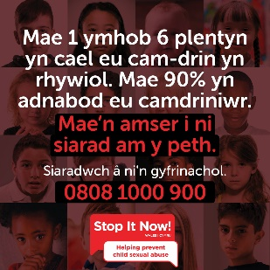
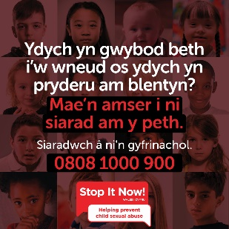 | 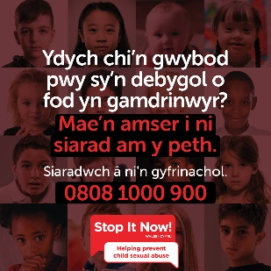 | 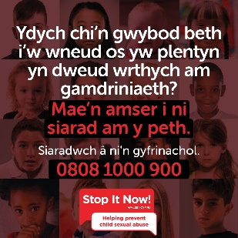 | 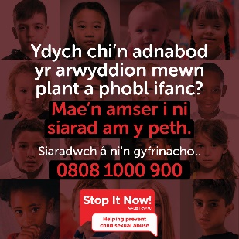
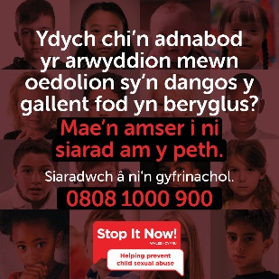 | 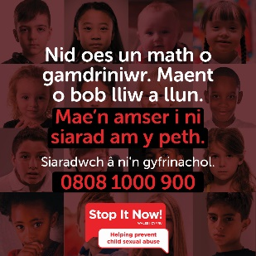 | 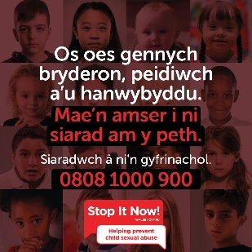 | 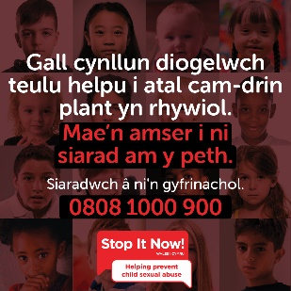
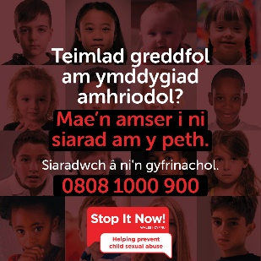 | 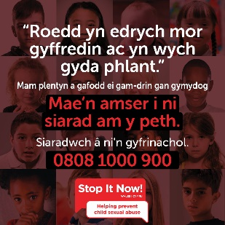 | 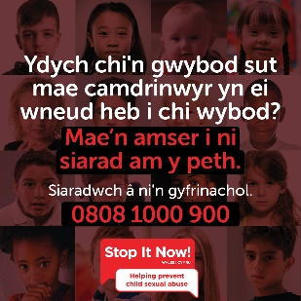 | 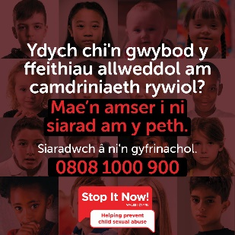

And you can contact us on wales@stopitnow.org.uk for more assistance.
4.2 Webpage
We have developed a dedicated webpage for this campaign on our website: https://www.stopitnow.org.uk/wales/its-time-we-talked-about-it/

Here visitors can find out more about the campaign and access support. Please feel free to create your own webpage and link to ours.

You can also link to the Stop It Now! Wales main page: https://www.stopitnow.org.uk/wales/

And our Parents Protect website: https://www.parentsprotect.co.uk/

If possible, you could include a statement of support for our campaign to prevent child sexual abuse on your own webpages.
4.3 Leaflets
A public information leaflet has been produced, in both English and Welsh.

You can download and print the pdfs here: https://www.stopitnow.org.uk/wales/its-time-we-talked-about-it/

Please feel free to use these as appropriate. And also do feel free to share them with other partner agencies and organisations if you think they may be able to use them.

To request printed copies, please email: wales@stopitnow.org.uk.

4.4 Posters
A series of poster are available, in both English and Welsh.

You can download and print the pdfs here: https://www.stopitnow.org.uk/wales/its-time-we-talked-about-it/

Please feel free to use these as appropriate. And also do feel free to share them with other partner agencies and organisations if you think they may be able to use them.

To request printed copies, please email: wales@stopitnow.org.uk.

4.5 Newsletter content
You can also signpost your support for the campaign and spread the message further by including information about it in your internal and/or external newsletters, intranets and other channels. You could use the copy provided below, or do contact us via wales@stopitnow.org.uk with any specific copy requests.

The ‘Child sexual abuse prevention – It’s time we talked about it’ campaign
A new campaign is running across Wales to raise awareness of child sexual abuse – and what we can all do to prevent it.
Run by Stop It Now! Wales, the ‘Child sexual abuse prevention – It’s time we talked about it’ campaign features awareness raising sessions for parents, carers and professionals – along with resources for each. Crucial messages are also being promoted through social media.
It is only in recent years that we have come to appreciate the true scale of the sexual abuse of children. The secrecy surrounding such abuse is evident in the fact that 1 in 3 children who are sexually abused by an adult do not tell anyone. Of those who do tell, most tell a family member or friend. Hardly any come to the attention of police, social services or health professionals. This is why is so important that we understand the risks, take protective measures and are confident to take action if we need to.
Key stats
- 1 in 3 children sexually abused by an adult do not tell anyone
- 4 out of 5 children abused by a peer told no one else at the time
- Only 1 in 8 sexually abused children are known to the authorities
- 90% of sexually abused children are abused by someone they know
- Around a third of sexual abuse is committed by other children and young people
- Disabled children are over 3 times more likely to be abused than non-disabled children
- There is no stereotypical abuser - abusers come from all walks of life – and from all socioeconomic backgrounds
Most victims of child sexual abuse don’t talk about it and can’t ask for help. So we, as adults, have to. By understanding the risks, and knowing what do to if we have a concern – we can prevent abuse from happening in the first place.
This campaign aims to provide adults with the information we all need to put in place preventative measures, recognise the warning signs of child sexual abuse - and build the confidence to do something about it.
The scale and secrecy which surrounds child sexual abuse means we all have a part to play in tackling it.
Information about the campaign is available here: https://www.stopitnow.org.uk/wales/its-time-we-talked-about-it/
And further information and resources are available on the Parents Protect website: https://www.parentsprotect.co.uk/
You can follow Stop it Now! Wales on Twitter: @StopItNowWales and find them on Facebook: https://www.facebook.com/stopitnowukandireland/ to help support the campaign and spread prevention messages.
The Stop It Now! Wales team can be contacted on wales@stopitnow.org.uk for more information.
4.6 Pre-planned events
Finally, you may wish to include details of the campaign at events you’ve got planned. You would be welcome to use any of the campaign assets detailed above. Do contact us via wales@stopitnow.org.uk with any specific requests.

5 Thank you
Stop It Now! Wales is incredibly grateful for any support you can offer.
Together we can prevent child sexual abuse.

